-
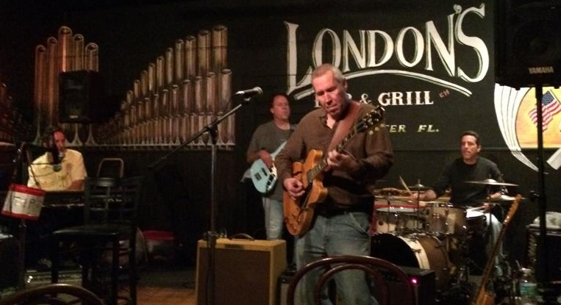
Now Booking Dates in the Tampa Bay Area

Bob Petrocelli is a singer/songwriter/musician with many years experience performing in a variety of styles. Since relocating to the Tampa Bay area in July of 2013, Bob has been appearing regularly playing a mix of classic and original blues, R&B, Memphis Soul, New Orleans & rock in solo, duo, trio, and quartet settings at various Bay area venues.

Prior to moving to Florida, Bob lived in NYC and perfomed with or opened for numerous artists over the years, including Paul Oscher (Muddy Waters Band), Robert Charels, The Nawlins Funk Band, Michael Hill's Blues Mob, Little Toby Walker, Jerry Nolan (NY Dolls), Patrick Sky, Johnny Maestro and the Brooklyn Bridge, The Del Satins, The Capris, The Dubs, The Devotions, The Ovations, The Elegants, The Ferrari Brothers, Minimalist composer Rhys Chatham, Jazz greats Richard Davis, Buster Williams, & Steve Swell, among many others.

In addition to leading his own groups and live performances, Bob has numerous recording credits including the new “Live At LP's” CD and his award winning 2008 solo CD release “Shanghai Shuffle” which received radio airplay in 16 countries and over 250 total radio markets worldwide.

Additional info including bio, videos, mp3s, press kit, calendar, photos, discography, etc. can be found at www.bobpetrocelli.com.
Contact info:
Telephone: 727-787-4597
Email: info@bobpetrocelli.com
Web: www.bobpetrocelli.com
Press Kit: www.bobpetrocelli.com

