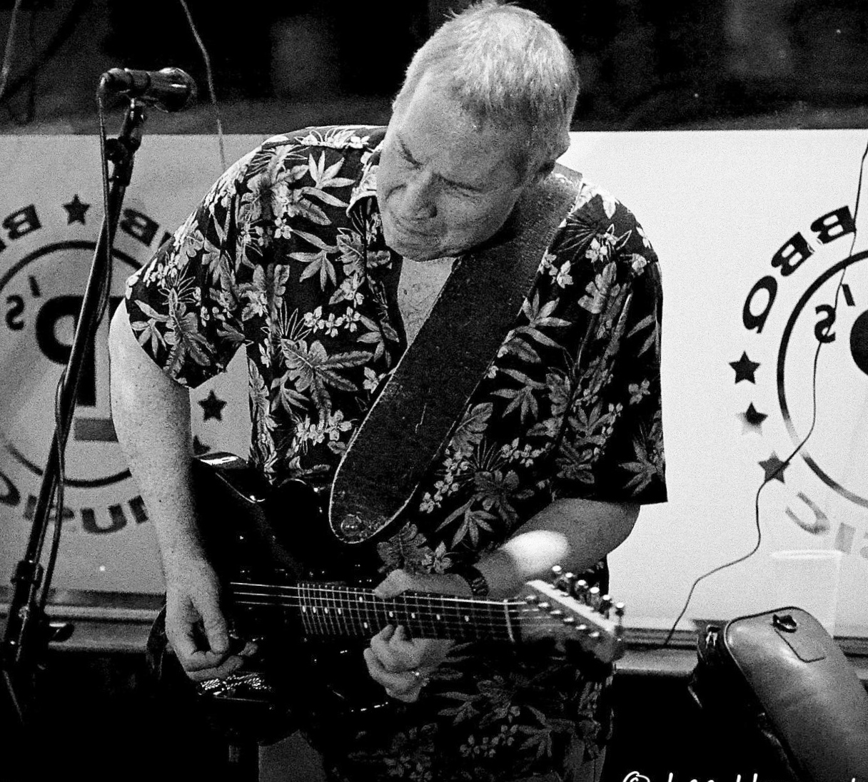
Bob Petrocelli

Multiple National/International recording credits as vocalist/guitarist/songwriter

Billboard World Song Contest – award winner - songwriting

Worldwide radio airplay on over 250 individual terrestrial and internet stations in 16 countries

Music licensed and played on Discovery Network, Travel Channel, etc.

Appearing regularly in Tampa Bay area since 2013 leading 3 & 4 piece bands as well as solo

www.bobpetrocelli.com

